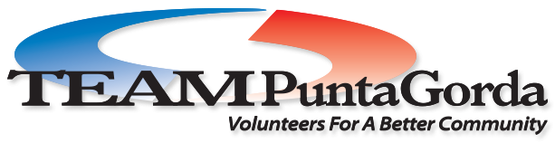

Strategic Plan

Mission: TEAM Punta Gorda is a volunteer-driven organization committed to making the greater Punta Gorda area a great place to live, work, and play.

(NOTE: See pg 6 addendum to strategic plan related to current Covid-19 situation)
.

ADOPTED by TEAM Board of Directors – June 1, 2020

TEAM PG Strategic Plan Committee

Lindsey Akins | Bob Bechtold
Corinne Carlson | Tom Cavanaugh
Adam Cummings | Sandy Dressler
Tom Gramza | Shelly Harris
Suzanne Herron | Nancy Johnson
Dan Kain | Peter Krumsiek
Elaine LaWell | Marianne Lilly
Kathy Oberle | Marilyn Pachota
Christopher Papa | Elisse Smotherman
Betsy Spagnolo | Hal Sterwerf
Vicki Welsch

Bill Welsch, Facilitator

Process
Meetings of the TEAM Punta Gorda Strategic Planning Committee were held on January 27, 2020 and February 24, 2020. The following work was accomplished at these meetings:

- Review, approval of TEAM PG Mission
- Record group responses with regard to what’s working/not working?
- Record responses to Critical Questions
- Summarize emerging issues, agree on actions moving forward
- Prepare spreadsheet summarizing goals, actions, persons accountable
- Agree on next steps in planning process

TEAM Punta Gorda

Mission: TEAM Punta Gorda is a volunteer-driven organization committed to making the greater Punta Gorda area a great place to live, work, and play.

Summary of Input: What’s Working, What’s Not

What Works
- TEAM continues to have much success with many different programs
- TEAM is able to recruit large numbers of volunteers for work projects
- TEAM is involved in a variety of wide-ranging community projects
- TEAM office under Corinne’s leadership is well-run
- TEAM is well-respected
- TEAM has a great relationship with city government
- TEAM has 15 years of momentum, of being a presence in the community

What Does Not Work
- TEAM needs to do better getting the word out about the organization
- TEAM needs to not lose sight of its origins regarding growth management
- TEAM has challenges recruiting volunteers to serve as leaders
- TEAM should get communities in greater PG area involved
- The public does not know what TEAM does
- TEAM has little social and print media presence
- There is no systematic approach regarding TEAM sponsors (in all areas)
- Although it has been considered, TEAM has no volunteer database
- There is no systematic approach to marketing
- There is no systematic approach to training new TEAM volunteers about the work
- TEAM does not have links on websites to partners such as the city
- There is no systematic approach to introduce TEAM to newcomers to PG
- Change in PG city manager could lead to a different relationship with the city

Critical Questions Facing TEAM Punta Gorda

- What actions will TEAM take to provide facilitative community leadership?
- What actions will TEAM take to Develop & maintain programs that improve the quality of life in Punta Gorda?
- What actions will TEAM take to mobilize volunteers for community service?
- What actions will TEAM take to Communicate our message effectively, both internally & externally?
- What actions will TEAM take to Build & sustain a strong TEAM Punta Gorda?
Summary of Participant Input RE: Critical Questions
- Journey to Future, a great example of bringing together many groups
- TEAM provide support for implementation of citywide plan, LDR changes, etc.
- TEAM to convene next level of JTTF to support implementation of citywide plan
- TEAM to convene various groups to “Think Green” and promote environmental issues such as water quality (Think: GREEN TEAM)
- Reach out to “greater PG” neighborhoods to offer support and assistance
- TEAM support efforts with regard to Charlotte HS homeless students
- Facilitate development of music programs for kids
- Work with youth groups to support their work
- Facilitate efforts to address human trafficking
- Facilitate arts organizations to create an arts area, perhaps at city Marketplace
- Do better at reaching out to neglected neighborhoods such as Eastside
- Need real, identifiable and focused ideas for boater friendly opportunities.
- Develop strategies to attract and retain TEAM volunteer LEADERS
- Pick projects where we have a sure win and promote, promote
- Stay focused on what we do well, don’t spread too thin
- Develop a speaker’s bureau and put them to work speaking
- Work with realtors to tell PG newcomers about TEAM
- Develop and implement a comprehensive fund raising and sponsorship program
- Create an endowment to assure long term viability of TEAM
- Develop a video orientation about TEAM
- Reach out to neighborhoods to ask how we can help
- Methods of funding administration such as by programs being charged admin percentage, need to be investigated and implemented
- Develop and implement a comprehensive communications strategy.
- Develop a marketing strategy including the possibility of funding a position.
Emerging Themes from Participant Input
- Return to “roots” by working with city to implement new Citywide Master Plan
- Collaborate with partners to act regarding clean water, healthy environment, beautiful city
- Develop fund raising/sponsorship program
- Develop strategies to recruit volunteers for TEAM leadership positions
- Develop an effective communication and marketing strategies

Addendum re Current Situation as of May, 2020: This plan is being completed during the COVID-19 virus emergency. Unusual circumstances such as social distancing, lack of ability to hold public gatherings, and other public safety measures may be in place for the foreseeable future. Committee and Board meetings are being held remotely using group conferencing tools such as Zoom. TEAM is mobilizing to be of assistance to the community in any way that it can. Efforts include:
- Participation in the COAD task force, developed by community partners to assist in emergencies
- Sharing Giving Challenge proceeds with the local COAD emergency relief fund to assist temporarily unemployed workers in the community.
- Organizing recurring food drives to help restock local food pantries such as St. Vincent DePaul.
- Raising funds for organizations that have feeding programs such as Backpack Kids and Meals on Wheels.
Many of the programs described in this plan are temporarily suspended. TEAM Punta Gorda will bring community initiatives back online in concert with the decisions made by City Council about re-opening the community.
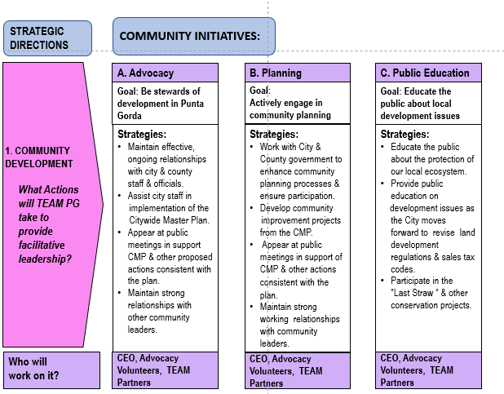

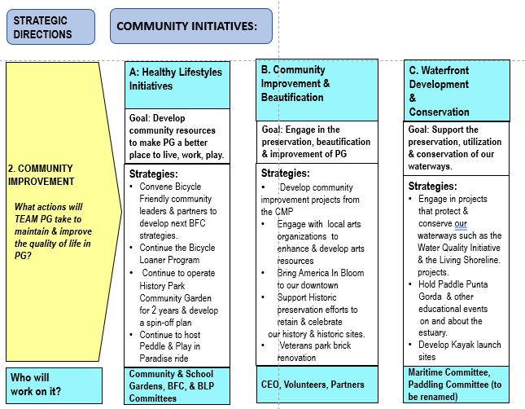

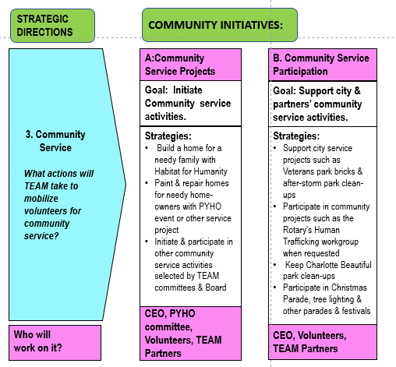

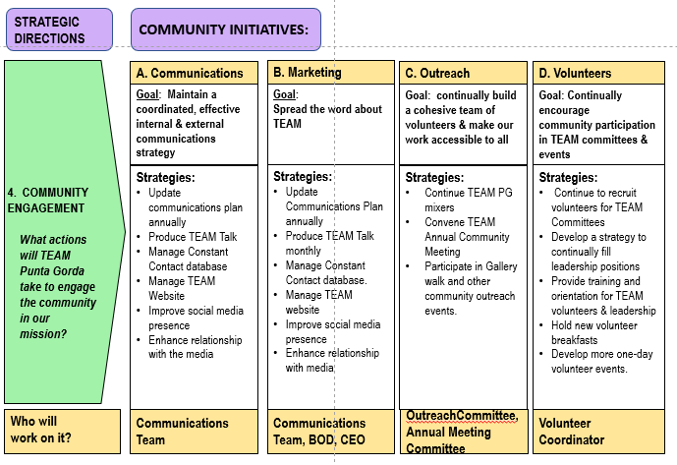

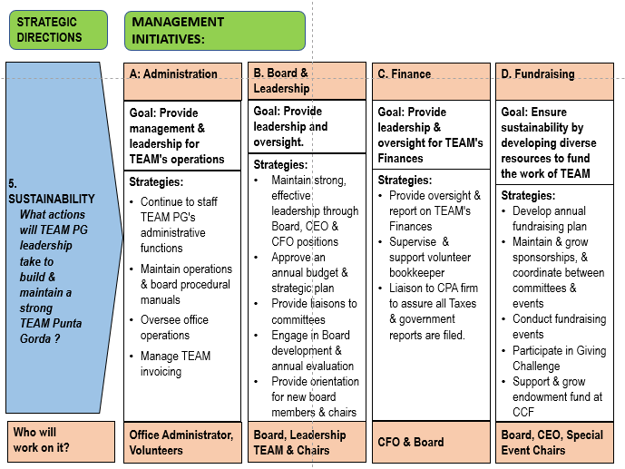

Addendum re Current Situation as of May, 2020:
This plan is being completed during the COVID-19 virus emergency. Unusual circumstances such as social distancing, lack of ability to hold public gatherings, and other public safety measures may be in place for the foreseeable future. Committee and Board meetings are being held remotely using group conferencing tools such as Zoom. TEAM is mobilizing to be of assistance to the community in any way that it can. Efforts include:
- Participation in the COAD task force, developed by community partners to assist in emergencies
- Sharing Giving Challenge proceeds with the local COAD emergency relief fund to assist temporarily unemployed workers in the community.
- Organizing recurring food drives to help restock local food pantries such as St. Vincent DePaul.
- Raising funds for organizations that have feeding programs such as Backpack Kids and Meals on Wheels.
Many of the programs described in this plan are temporarily suspended. TEAM Punta Gorda will bring community initiatives back online in concert with the decisions made by City Council about re-opening the community.

